Project 1, Group 5  
Individual Contribution of Girts Dvinskis

**Sprint 1:**

During the first sprint of this project I had the task of making **the early mechanics and rules** of our game. This was done to make sure the paper prototype we were tasked with making in that sprint was playable, and anyone wanting to try it out had a sense of what the game would be about and how it would be played

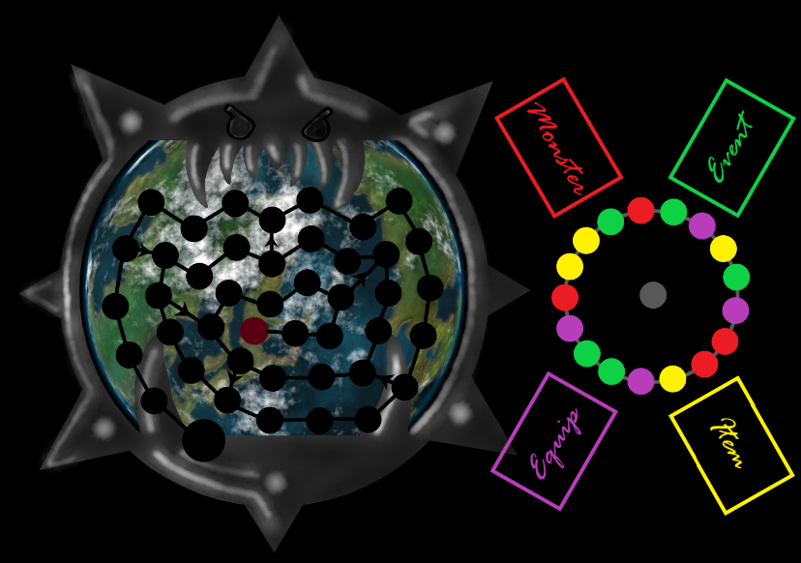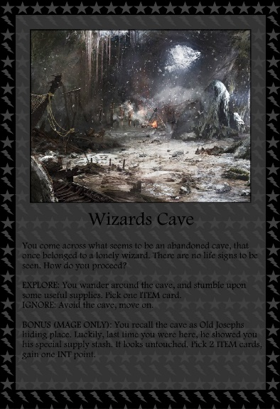During the first sprint I also designed a basic early design of our board and an example of a card. Both of these did not end up being used in the final game, as we chose a different design for the board, and decided that the card did not fully suit our needs (hard to read and not particularly eye catching).

**Sprint 2:**

During the second sprint I was the scrum master. We had the task of making a finalized manual of our board game. The manual was split up into multiple different parts. Out of all the parts I chose to:

* Write out the early game setup (How the players must set up their characters, the board and anything else they might need)
* Basics guidelines of playing the game (A short explanation on how the game starts, what situations might occur and what the players would have to do in these situations. This was made to give any new players a short insight in how the game would be played)
* The mechanics of the cards used in the game (So an explanation of all the card types, how they differentiate from each other and how the work exactly)
* Keeping a track of the rulebook (This included following play testing sessions and noting down any mechanics that could be misused, and making up rules to make the game fair for everyone taking part)

**Sprint 3:**

In sprint 3 our task was to finish off the whole game. At the start of the sprint I was tasked with finishing up the manual (making sure all the different parts were ready to be put together and printed out by the rest of the team). I also worked closely together with the team to figure out the stats of the World Eater. This mostly included playtesting and testing out various states of the world eater, making sure they are neither too weak nor too strong.

During this sprint one of our group members, Shirley, stopped following the Informatica course. For the 3rd sprint she was tasked with creating the cards. As she left, I took over her task of finishing off any cards that weren’t done yet and modifying most of the done cards as we needed a different layout for most of them.

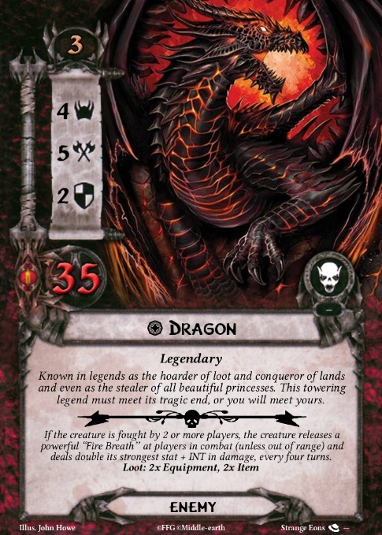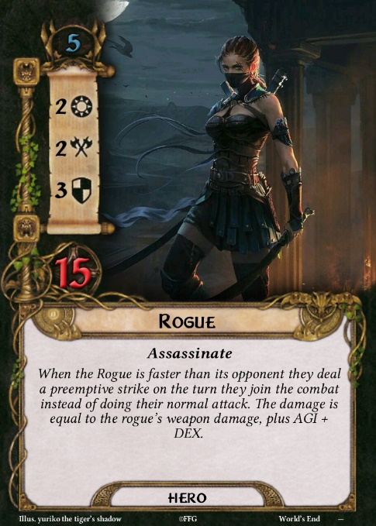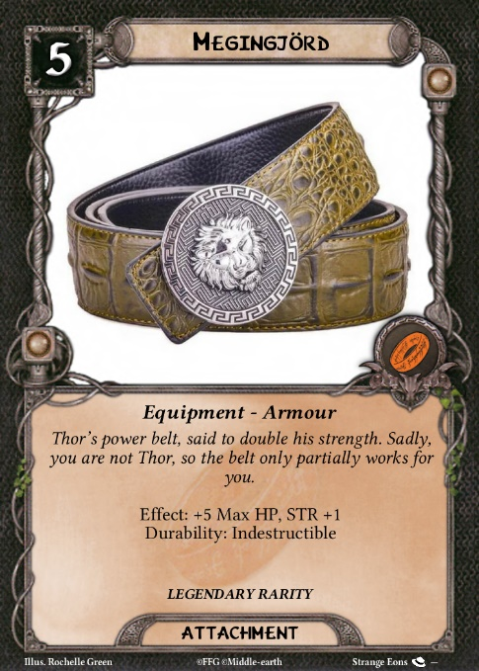This included looking for images (which I thankfully got the help of the rest of the group for), finding suitable layouts for the different types of cards we had, typing out over 100 different cards (stats, descriptions etc.) and making sure they were all ready to print. After printing we as a group worked together to cut all the cards out and ‘laminate’ them in our own way.

**Sprint 4:**

During sprint 4 we had to make a prototype of the digital component. I chose to code an inventory management system, that would work together with a stat tracker system made by a different team member and allow players to add cards they’ve acquired to their inventory, modifying the appropriate stats if the player. Unfortunately, the inventory system proved a bit too difficult, which is why I didn’t manage to finish it in time and had to work on it during the next sprint.

**Sprint 5:**

In sprint 5 we were tasked with finishing the whole digital component. As I was not yet done with my task from sprint 4, I continued working on that.

Between the end of sprint 4/the start of sprint 5 another one of our members left the school. This time it was Sarah. She had the task of making a virtual die and a (global) turn tracker. She finished both of these items, but I modified some of them, adding some extras, and working on incorporating them into my program to make some progress on adding all of the individual components into one.

**Sprint 6:**

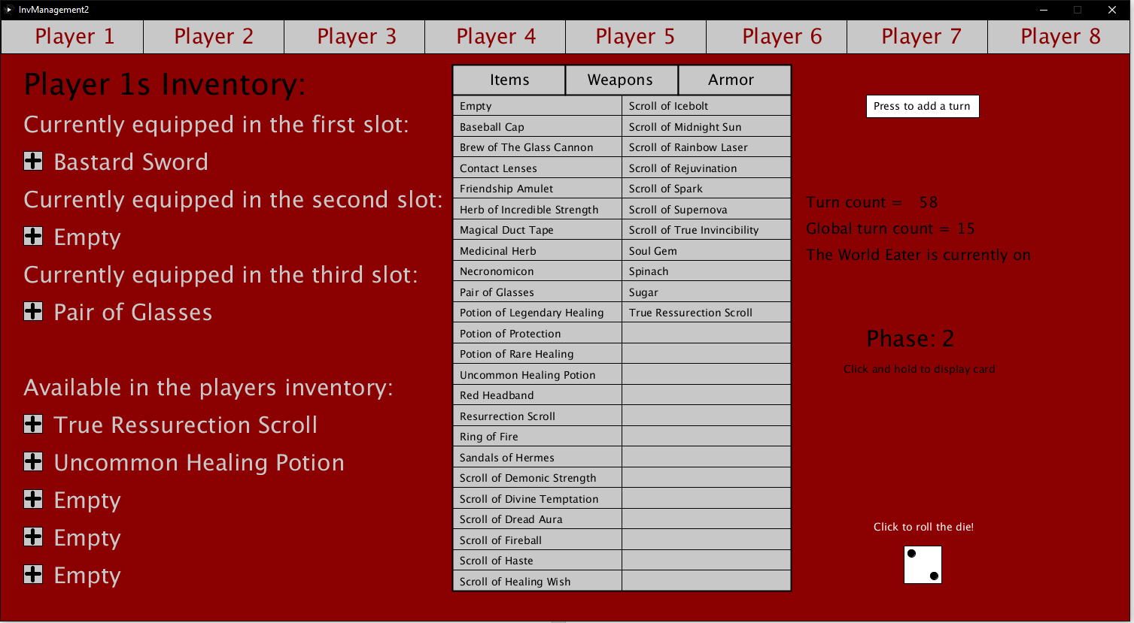Sprint 6 was the final sprint of this project, which meant everything had to be fully finished. During this sprint I finished my program (fixing issues with flashing screen and random stuff not working as wanted). I also finally incorporated Sarah’s components into my program. The team then worked together to get all the individual programs into one program. We also got ready to present the game and compiling any loose documentation into one piece.